JOUR 4251
Psychology of Advertising 1.2 Functions of advertising / introduction to psychology
Personal statement & Course agreement
● First 5 points!
● Complete by Jan 30 before class starts (2:30 pm)
To do:
1. Please provide 5-10 sentences about yourself, including your interest in this course, your major, what you hope to gain from the course, and career goals. There are no right or wrong answers – this is your opportunity to tell us what you want to learn from the course and how your interests/career goals may relate to the course.
2. Read syllabus and ask questions about things that are unclear
3. Sign the course agreement to state that you have read and understood the course requirements.
Install LockDown browser
(Tip: on laptop that you are planning to use for the exams!)
INSTALL lockdown browser
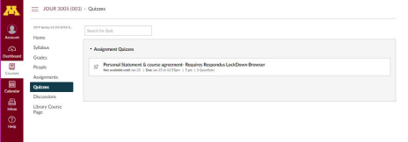
You can NOT make the
assignment or take the exam
without the LockDown browser.
Downloading may take some time.
Make sure it works.
Only have to download once.
Contact TA when having issues
1. Go to our Canvas page > Quizzes
2. Choose “Personal statement & course agreement” 3. Click “Take survey”
4. Click “Download respondus LockDown Browser” 5. Open LockDown browser > Choose Canvas (pilot) 6. Log in with own credentials and repeat step 2 & 3.
with downloading/opening LockDown browser.
Do NOT wait until the last minute!
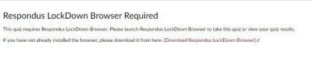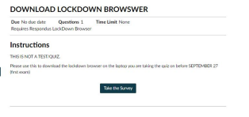
Recap
● Advertising
○ Paid
○ Placed
○ Consumer-based
● Brand
○ Unique Selling Proposition
● Why advertising?
○ Facilitates competition
○ Way to communicate with (potential) customers ○ Key source of funding for media and other industries
Functions of advertising
1. INFORM
Creating or influencing non-evaluative responses, such as beliefs.
2. PERSUADE
Generating or changing an evaluative response, such as that something is more favorable.
Depends on:
1. Type of Product
2. Type of Purchase
3. Lifecycle of the product (introduction, growth, maturity, decline) 4. Situation, crisis
Can you think of any examples of hard-sell or soft-sell advertising?
What works best for you? Why? Why not? In what context?
Approaches
Hard-sell approach
● Informational
● “Reason why approach”
● Used to be “tell approach”: inform customers what was for sale at what price and where once could buy it.
Soft-sell approach
● Emotional; affect=based appeal
● Influence feelings, emotions (rather than thoughts)
They coexists today
May dependent on: agency, client, product, target audience, etc.
Strategies
ALPHA strategies
Influence the tendency to MOVE TOWARD something Approach motivation
OMEGA strategies
Influence tendency to MOVE AWAY from something Avoidance motivation
Psychology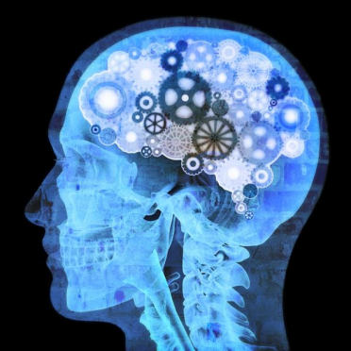
Psychology approach to advertising
Identifying the EFFECTS of advertising at the INDIVIDUAL level.
Seeks to articulate the intrapersonal, interpersonal, group-level PROCESSES (cognitive, in the mind) that are responsible for the relationship between advertisement and the response.
Psychology
ACTIVE processing…
We come to messages with schemas and ideas already in place.
We are active in evaluating the messages.
We respond in many different ways
Effect
How you know what you know?
How do you know if something is true? What do you need as evidence?
How you know what you know?
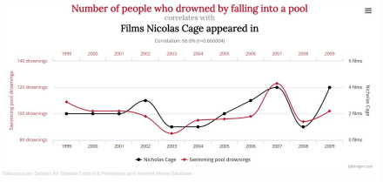
Social psychological approach
Theory-based
Experiment-based
Predictive models
Correlation versus causation
How you know what you know?
Theory helps us to understand the world around us Research is needed to test it
Experiment will help us to test effects
We can predict how people will interpret advertisements
Experiment
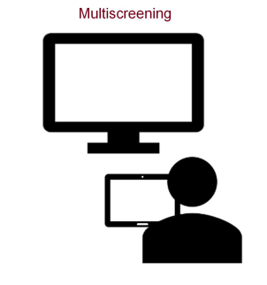Single screening
Experiment

Group 1
Congruent character
Group 2
Incongruent character
Experiment
1. We manipulate 1 thing that we are interested in (cause)
2. Assign participants to one group/message
3. Ask questions - measure outcome (effect)
Independent variable = what we manipulate (cause)
Dependent variable = the outcome (effect), for example, attitudes, behavior, intentions, memory
How do we isolate the effect of the message?
● Change only 1 thing between groups in message/task
● Random assignment
Everybody has an equal chance of being in a group so any difference between groups is related to the independent variable.
What makes the difference?
Many factors can make the difference between whether an ad is effective! You have factors related to...
● The message
● The sender
● The receiver (consumer)
● Etc.
We will look at some of those.
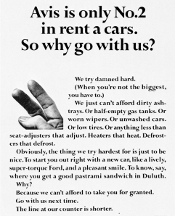
Message characteristics
Argument-based vs. Affect-based appeals
Message sidedness
One-sided: only presents claims in support of position
Two-sided: presents positive and negative or supporting and counter arguments
Source of the message
Who is the source?
Direct source
Spokesperson delivers the message (speaking or demonstrating use of product)
Indirect source
Associated with the product, but not delivering the message (not speaking/demonstrating)

Who is the source?
Direct source
Spokesperson delivers the message (speaking or demonstrating use of product) In example: Katy Perry
Indirect source
Associated with the product, but not delivering the message (not speaking/demonstrating) In example: Kendell Jenner
A logo for a company is also indirect
Source effects
Credibility - expertise, trustworthiness
Attractiveness - rubs off on product
What’s next?
● Continue reading chapter 1
○ Reading response due Jan 30 before class starts (2:30 pm)
○ Hand in on Canvas: upload Word or PDF document
● Submit assignment 1 by Jan 30, 2:30 pm
○ Install LockDown Browser on the laptop your planning to use for the exam
● Set up notification in Canvas for announcements asap
○ See slides of Tuesday for the instructions
Questions? Email one of the teaching assistants (TAs).
Contact information is available on Canvas.
TA sections will be announced on Tuesday.

